Purpose and Target Audience  The Palm Beach County Chapter of the Oncology Nursing Society presents an educational conference providing education for ONS members and other oncology healthcare professionals.  The target audience includes oncology nurses and oncology allied professionals.  ___________________________________  COURSE OBJECTIVES  __________________________  Upon the completion of this event, the participant will be able to:  Understand the current landscape of biosimilar development, research, and clinical use.  Clarify misperceptions about biosimilar therapy comparability to reference products.  Understand science of hereditary genetics, genetic alterations, and correlation to cancer disease.  Apply the newest hereditary cancer screening guidelines in practice.  Stimulate thought & conversation about contemporary media and how it has affected the perception of cancer diagnosis, care, and prognosis in patients and their caregivers. | REGISTRATION _______________________  3.0 CEU’s  Continuing credits provided by Leukemia & Lymphoma Society  Accredited by ANCC.  Register Online:  www.palmbeachons.com  Early Registration:  Registration fee $26  Early Registration Deadline:  October 15, 2019  Late Registration (after Oct. 15th):  Registration fee $35  Last date to register:  October 30, 2019  Registration includes valet, breakfast and lunch, 3 informative oncology lectures, and CEU educational credit.  First 100 registrants will be eligible to win a 1 year paid ONS membership!  Please note:  No registrations will be accepted on the day of the event. | 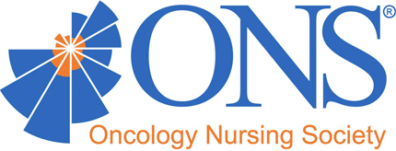  “Sunshine State  of Mind”  24th Annual South Florida Tri-County Educational Conference  ≈  Saturday, November 2, 2019  Mizner Country Club  16104 Mizner Club Drive, Delray Beach, FL 33446  First 100 registrants will be entered into a raffle for a 1 year paid ONS membership!
Program Agenda  8:00-9:00  Registration and Breakfast  Exhibit Hall  9:00-9:15  Welcome  Dawn Paynter, APRN, AOCNP  President PBONS  9:15-10:00  The Current Biosimilar Landscape  Kennon McCollum, DNP, APRN-BC  Oncology Nurse Practitioner/Director of  Survivorship Services  10:00- 10:30  Break and Exhibits Open  10:30-11:15  Clinical Update in Hereditary Cancer Screening  Conni Murphy, APRN  Director, Cancer Genetics & High Risk Clinic  11:15-11:45  Break and Exhibits Open  11:45-12:00p  Door Prizes and Giveaways  12:00-1:15p  Lunch & Keynote Speaker  Cancer in the Media: Changing the  Conversation  Barbara Abernathy, PhD, LMHC  NCC Certified Licensed Mental Health Counselor  Director of Pediatric Oncology Support Team  1:15-1:30p  Closing Remarks | - Keynote Speaker  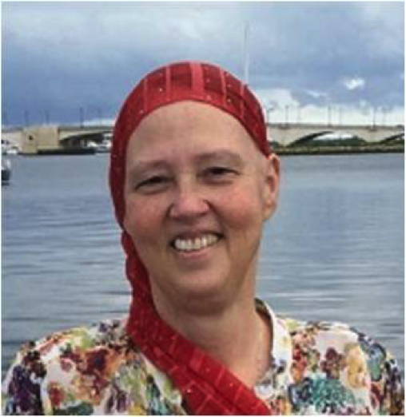  Barbara Abernathy, MS, PhD, LMHC  Barbara Abernathy, PhD, LMHC, is the President and CEO of the Pediatric Oncology Support Team, Inc. (POST), a nonprofit helping children and their families cope with the devastating effects of cancer. She has 30 years’ experience in nonprofits, 20 of those years at POST. She has a PhD in Counselor Education and Leadership from Florida Atlantic University (FAU), Master of Education in Counseling from the University of South Alabama, Master of Science in Biology from FAU, and a Bachelor of Education in Human Development and Social Policy from Northwestern University. She is adjunct faculty at the University of Miami Miller School of Medicine and at FAU. Other professional experience includes pediatric AIDS, bereavement, family counseling, parent education and treatment of severely abused children. | 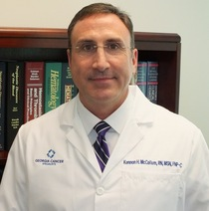  - Kennon McCollum, DNP, APRN-BC  - Dr. Kennon is a member of the American Academy of Nurse Practitioners, the Southern Crescent chapter of the Oncology Nursing Society, Sigma Theta Tau Honor Society for Nursing, Phi Kappa Phi Honor society, the International Nurses Association, and Golden Key Honor Society. He has also has served as adjunct clinical faculty for Emory University, Georgia State University, University of Southern Alabama, DeKalb Community College Schools of Nursing, and the University of Alabama DNP program. Kennon authored a chapter in an oncology textbook and has published cancer related articles in oncology peer reviewed nursing journals. Kennon is also a nationally recognized chemotherapy nurse educator and serves on several industry sponsored chemotherapy speakers bureaus and advisory panels. In 2016 Kennon was inducted into the International Nurses Association and was recognized as one the top Nurse Practitioners in the State of Georgia. Kennon provides care to all cancer and hematology patients, and has a special interests in the hematologic cancers, cancer survivorship; and currently serves as the survivorship coordinator for Georgia Cancer Specialists.  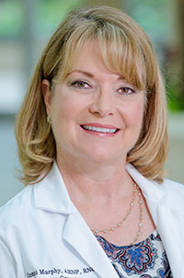  - Conni Murphy, APRN  - Conni Murphy received her Bachelor of Science in Nursing at Florida Atlantic University in Boca Raton, Florida and completed her Nurse Practitioner training at Emory University in Atlanta, Georgia. She holds two national certifications with the National Certification Corporation (NCC) in Women’s Health as well as Reproductive Endocrinology and Infertility. After enjoying 23 years in private practice, Conni went on to receive specialized training in Cancer Genetics and Cancer Predisposition Counseling through the City of Hope in Duarte, California. Conni is a true Floridian, born and raised in South Florida. Conni is the Director of Jupiter Medical Center’s High Risk Genetics Clinic.

